VS Log-In Details

Contact Information
Presentation Secondary School,
Gogans Road,
Wexford

Dear Parent/Guardian,

Please visit the website – https://preswex.vsware.ie
Or alternatively, go to the school website www.preswex.ie and click the VSWare tab at the top.
Login with your username and password – to follow.

This will enable you to access your daughters Term Reports, Attendance, Behaviour and Timetable and pay Fees.

This is the preferred method of payment and fees paid by this method are at a reduced rate with no bank charges. To pay fees, please click the Fees tab down the left hand side, select the fee(s) you wish to pay for and click Pay. You will be prompted to select a card type and enter payment amount.

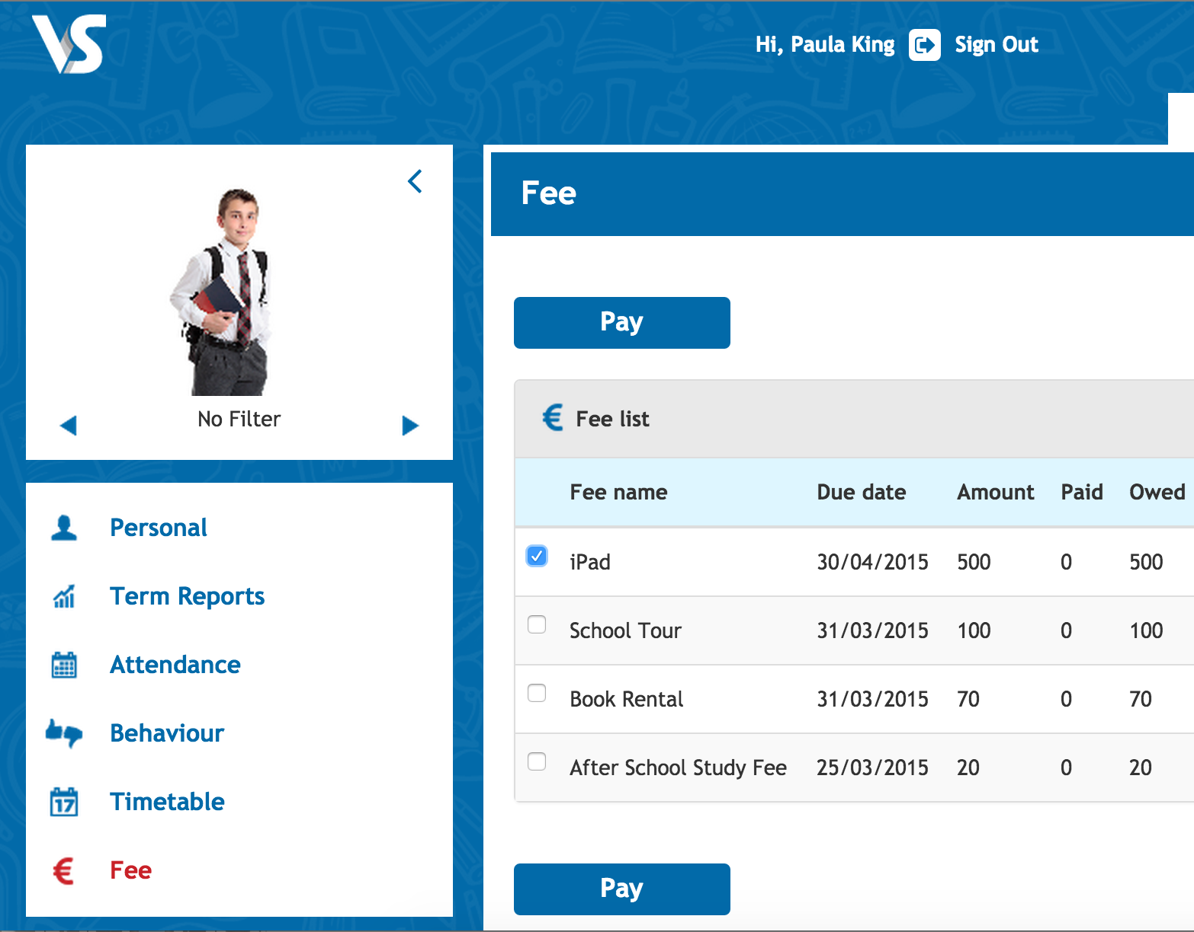

PTO
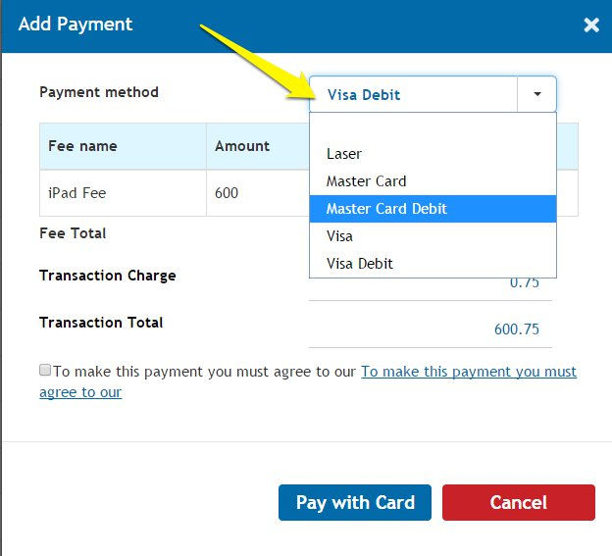

Please tick on the payment method box to choose what method of payment you wish to use
Please note log-in details are case sensitive and may include numbers and keyboard symbols.

