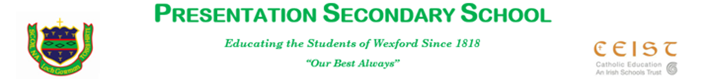

**Assistance towards the cost of school books in Presentation, Wexford-2018/2019**

Dear Parents/Guardians,

The Department of Education and Skills (DES) offers assistance towards the cost of school books for families who are experiencing genuine financial hardship.

The DES guidelines defined the situations where genuine financial hardship may exist as being one or more of the following:

* Unemployment/short-term working
* Prolonged illness of a parent/guardian
* Large family size with inadequate means
* Single parent/guardian families
* Other family circumstances indicating financial hardship

Indications of inadequate financial means include the following:

* Families dependent on social welfare
* Families eligible for Family Income Supplement (FIS) or the Back to School Clothing and Footwear Scheme

Entitlement to a medical card does not necessarily indicate eligibility.

In order to enable the school to allocate its 2018/2019 fund in the fairest way possible, I now request parents/guardians who fulfil the criteria above to complete an Application Form.

The form must be returned to me on or before 12.00 p.m. on Friday 1st June 2018.

This form is available on the school website or for collection at the school general office.

Given the sensitivity of this issue, I want to assure you that all applications will be treated with the utmost confidentiality.

Yours faithfully,



William Ryan,

**Principal**

